Exp no:8 -Determination and plotting of Capacitance of Co-axial cable per unit length with different (i)
inner radius, (ii) outer radius and (iii) relative permittivity of the dielectric medium.
Aim:
To write program for Capacitance of co-axial cable per unit length using SCILAB.

Software required:
•SCILAB version 6.0.1
Theory:
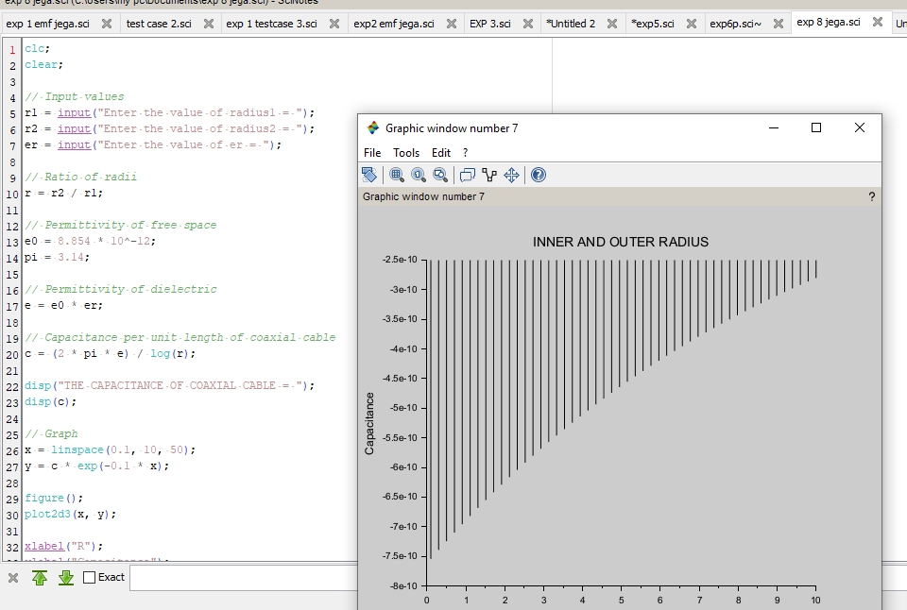

OUTPUT :

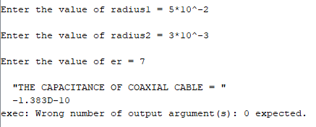
CALCULATIONS :
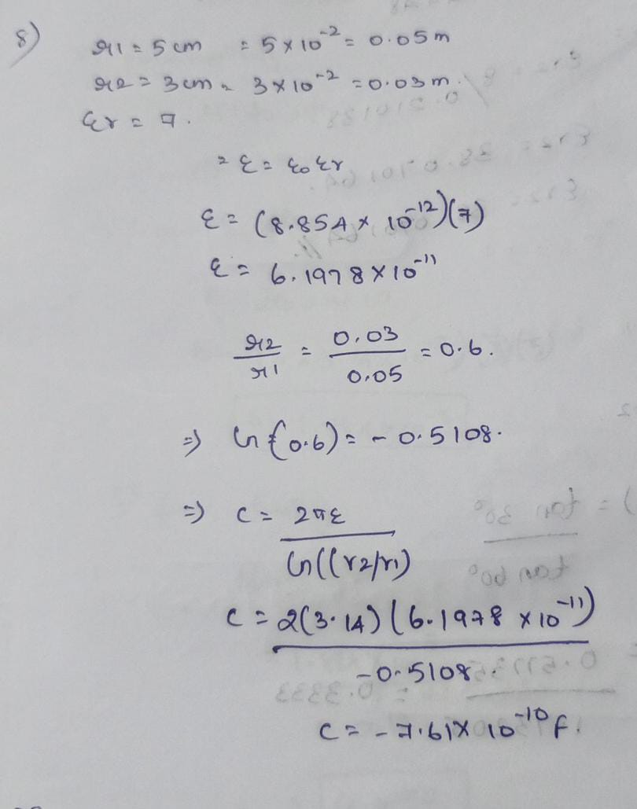
CASE STUDY 1: Variation with Inner Radius
